CREATIVE CORNER

HOPE

**AN ANONYMOUS PMC STUDENT**

The image depicts hope in adverse circumstances. The dull colour scheme of the back drop and lack of detailing on the ground illustrated absence of opportunities and ceased possibilities causing a state of despair. Whereas the horizon carried heavenly bodies depicting new worlds of opportunities, stars to represent

hope and birds to illustrate possible libration from adverse ground realities. The subject has opened his arms to the new hope given by an emerging light that has started to appear in the horizon. Overall the image related that in contrast to the fixation on subtle ground realities, opening up to new possibilities inculcated hope.

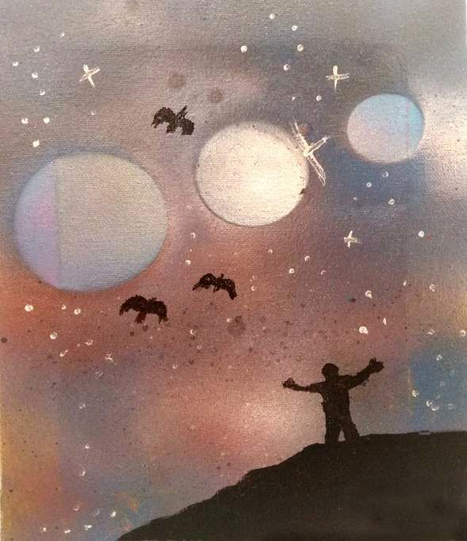

*PAGE 24 APRIL - JUNE 2021 VOLUME 18 NUMBER 2*